W4-S2 PRACTICE
CSS FLEXBOX

 At the end of this practice, you should be able to…
- Manipulate CSS flexbox attributes
- Identify the CSS flex attributes in different use cases

 How to work?
- Download the start code from the LMS
- Open the folder in VS Code

How to submit?
- Push your final code on your GitHub repository
- Then attach the GitHub path to the MS Team assignment and turn it in

 Are you lost?
You can read the following documentation to be ready for this practice:
- Guide - WC3 School
- Guide - Flexbox properties
- Video – Flex in 10 minutes!
- FLEX EXPLORER

EXERCISE 1
Using flexbox, build the layout pictured below.

Warning: No absolute positions, no CSS frameworks, no JavaScript. Only flexbox!
Note: Start code is provided for this exercise!

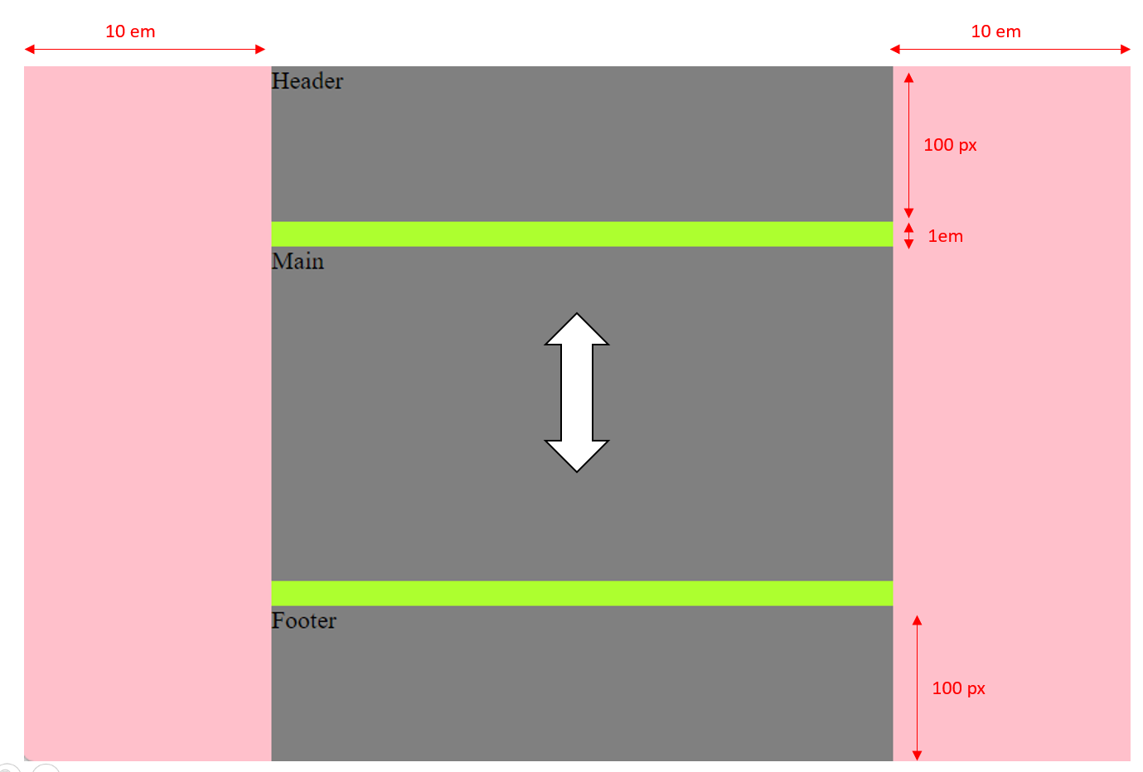

 Are you lost?
TIP 1 - Here are the CSS properties involved in this exercise:
• display
• flex-grow
• flex-direction
• gap
• height
• padding-left
• padding-right

EXERCISE 2
Using flexbox, build the layout pictured below.

Warning: No absolute positions, no CSS frameworks, no JavaScript. Only flexbox!
Note: Start code is provided for this exercise!

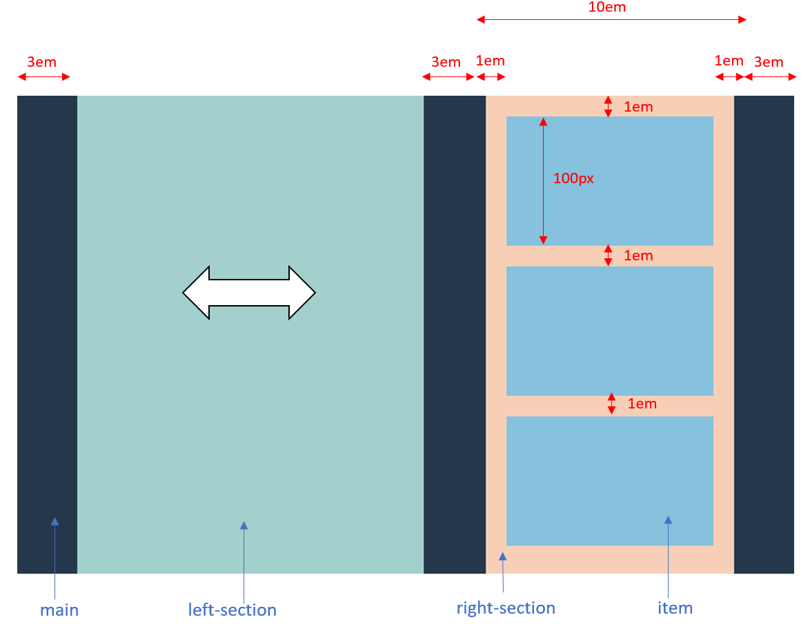

 Are you lost?
TIP 1 - Here are the CSS properties involved in this exercise:

- display
- flex-grow
- flex-direction
- gap

- height
- width
- padding
- padding-left
- padding-right

TIP 2 - Flexbox child element can also be a Flexbox container of other elements.
As example here The light orange box serves two purposes:
- it is the child element of the dark blue container
- but it is also a flexbox container itself, containing two lightblue child elements.

TIP 3 – You should process step by step: starting from the parent containers and going gradually to the children
- First focus on the left and right divs
- Then focus on the right div inner items

EXERCISE 3
Using flexbox, build the layout pictured below.
Warning: No absolute positions, no CSS frameworks, no JavaScript. Only flexbox!

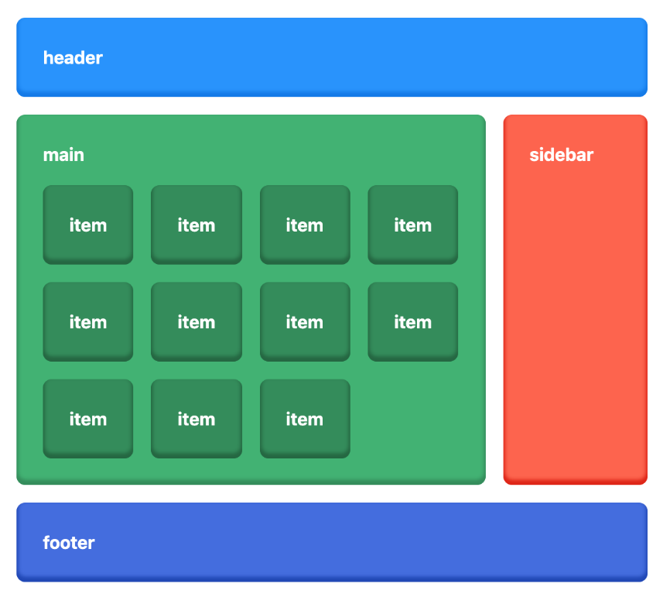

 Specifications
- Border radius is 0.5rem
- Use the colors as specified
- Spacing between everything is 1rem
- The shadow is there just because I like it! you don't need to have it

 | Background | Shadow
header | #1e90ff | #0077ea
main | #3cb371 | #2f8d59
item | #2f8d59 | #226741
sidebar | #ff6347 | #e02200
footer | #4169e1 | #1d44b8
Color specification

- The growing policy for each section is defined as follows:

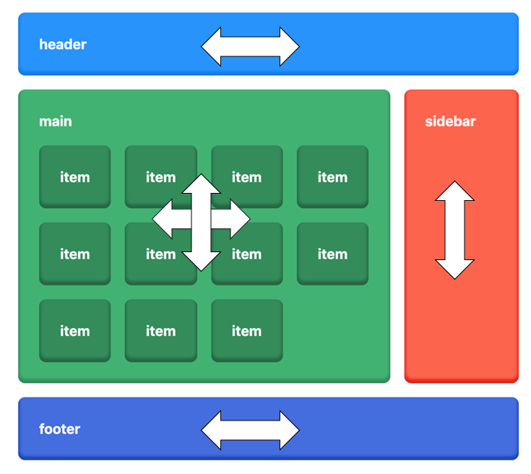
- The main section should grow until the footer. Even without any item
